**Tableau Architecture**

**Tableau Server Architecture**

**Tableau has a highly scalable, n-tier client-server architecture that serves mobile clients, web clients and desktop-installed software.Tableau Server architecture supports fast and flexible deployments.**  
 **The following diagram shows Tableau Server’s architecture:**

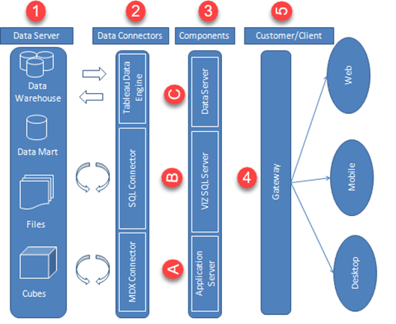

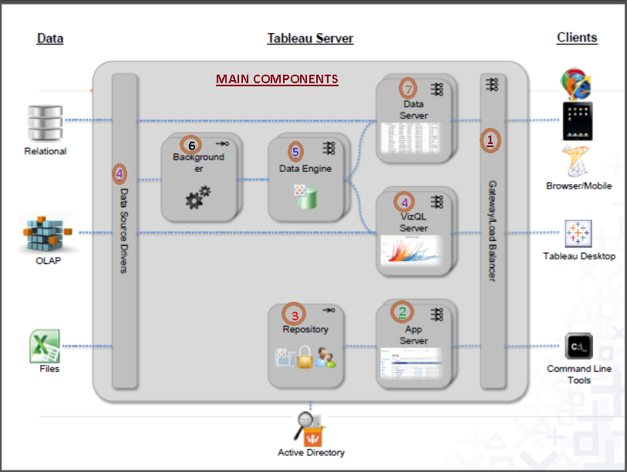

**Tableau Server is internally managed by the multiple server processes.They are**

**1)Gateway/Load Balancer:-**

**It acts as an Entrygate to the Tableu Server and also balances the load to the Server if multiple Processes are configured.**

Gateway/ Load Balancer The Gateway is the primary Tableau Server that routes requests to other components. Requests that come in from the client first hit the gateway server and are routed to the appropriate process. If multiple processes are configured for any component, the Gateway will act as a load balancer and distribute the requests to the processes. In a single-server configuration, all processes sit on the Gateway, or primary server. When running in a distributed environment, one physical machine is designated the primary server and the others are designated as worker servers which can run any number of other processes. Tableau Server always uses only one machine as the primary server.

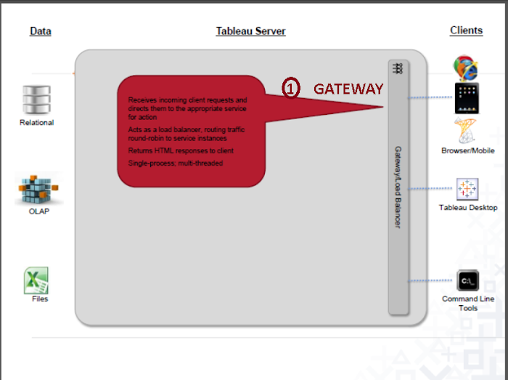

**2)Application Server:-**

**Application Server processes (wgserver.exe) handle browsing and permissions for the Tableau Server web and mobile interfaces. When a user opens a view in a client device, that user starts a session on Tableau Server. This means that an Application Server thread starts and checks the permissions for that user and that view.**

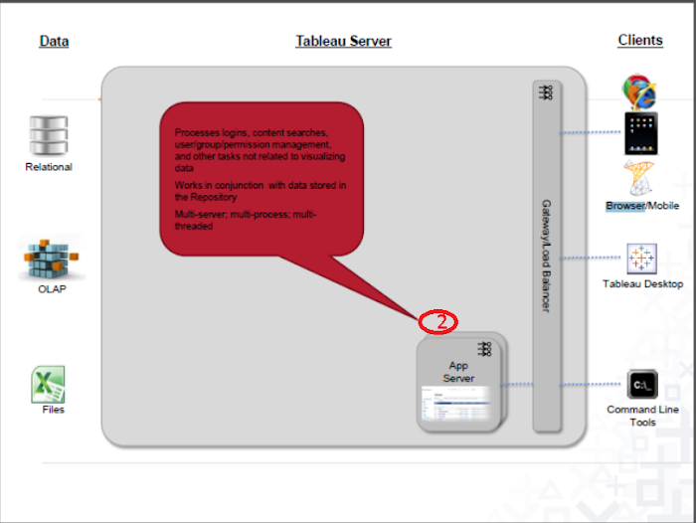

**3)Repository:-**

**Tableau Server Repository is a PostgreSQLdatabase that stores server data. This data includesinformation about Tableau Server users, groups and group assignments, permissions,projects,datasources, and extract metadata and refresh information.**

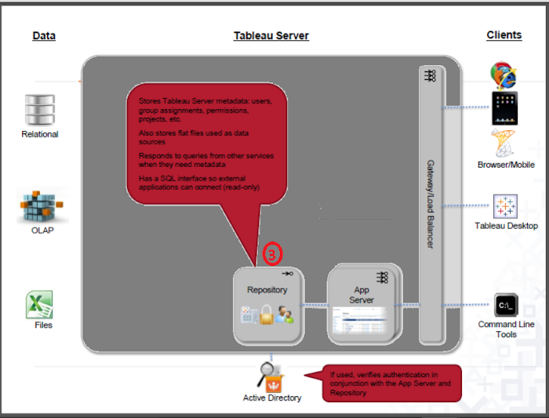

**4)VIZQL Server:-**

**Once a view is opened, the client sends a request to the VizQL process (vizqlserver.exe). The VizQL process then sends queries directly to the data source, returning a result set that is rendered as images and presented to the user. Each VizQL Server has its own cache that can be shared across multiple users**

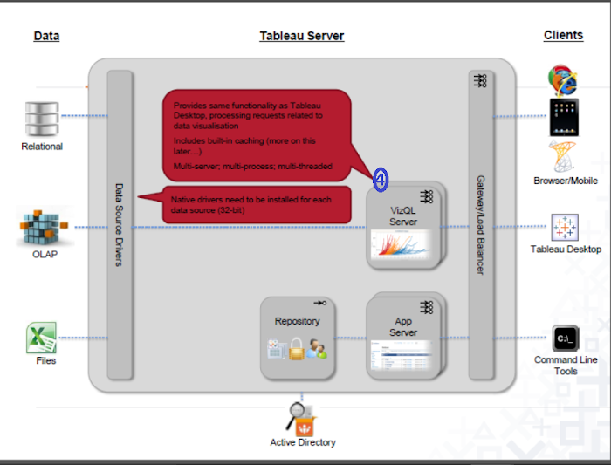

**5)Data Engine:-**

**It Stores data  extracts and answers queries**

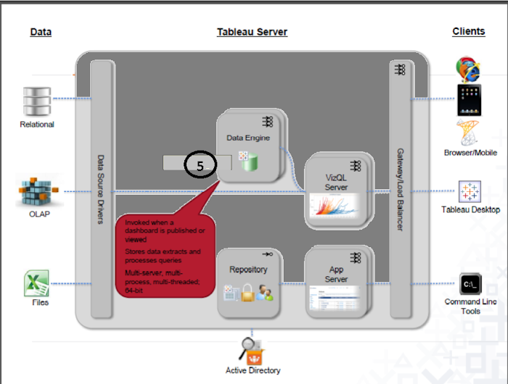

**6)Backgrounder:-**

**The backgrounder Executes server tasks which includes refreshes scheduled extracts,tasks initiated from tabcmd and manages other background tasks.**

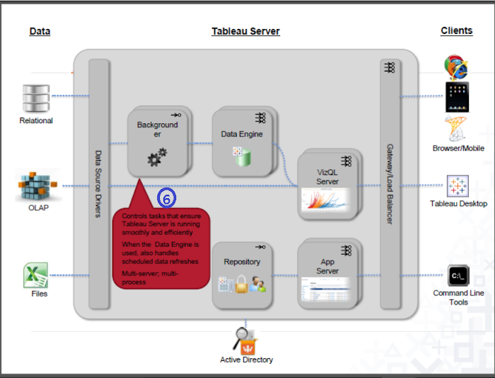

**7)DataServer:-**

**Data Server Manages connections to Tableau Server data sources**

**It also maintains metadata from Tableau Desktop, such as calculations, definitions, and groups.**

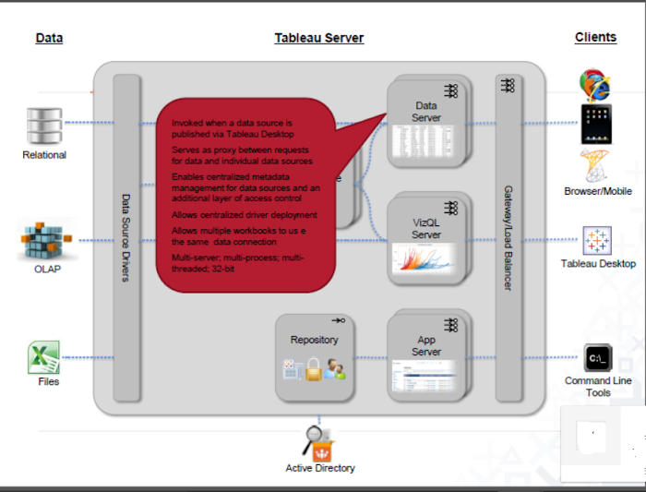

# [TABLEAU GURUS](http://tableaugurus.blogspot.com/)

* [Home](http://tableaugurus.blogspot.com/p/home.html)
* [Articles](http://tableaugurus.blogspot.com/p/articles.html)
* [Tableau Videos](http://tableaugurus.blogspot.com/p/t.html)
* [Data Science Videos/Articles](http://tableaugurus.blogspot.com/p/data-science-videos.html)
* [Challenges](http://tableaugurus.blogspot.com/p/challenges.html)
* [Tableau Server Interview Questions](http://tableaugurus.blogspot.com/p/tableau-server-interview-questions.html)
* [R](http://tableaugurus.blogspot.com/p/r.html)
* [Alteryx](http://tableaugurus.blogspot.com/p/alteryx.html)
* [TableauCertification/Training](http://tableaugurus.blogspot.com/p/tableau.html)

Top of Form

|  |  |
| --- | --- |
|  |  |

Bottom of Form

### Tableau Server Interview Questions

**Hello Guru's**

**I always got some emails asking about Tableau Server interview questions,Finally I'm listing them below.**

**1. What is TABLEAU SERVER and how it differs with the TABLEAU DESKTOP?**

**A.Tableau Server is a Web Server, means it requires a mediator component known as Web Browser. Tableau Server allows Users to Perform browser based Visual Intelligence.**

2.What is the minimum RAM required to install TABLEAU Server? 

**A.32 GB (PRODUCTION)**

**8 GB (NON-PRODUCTION)**

**3. What are the different OS supported by the TABLEAU Server?**

**A. It supports only WINDOWS platform.**

**4. Explain the TABLEAU Server Configuration Settings?**

**5.What are the different types of user authentications available in the TABLEAU Server?**

**A.In TABLEAU server there are 2 types of USER authentication.**

**1. LOCAL AUTHENTICATION        .2. ACTIVE DIRECTORY**

**6. Is it possible to change user authentication within one single installation or not?**

**A. NO, it is not possible.**

**7. What is Cache?   .**

**8.What are the different ways to handle cache in TABLEAU Server?.**

**A.In TABLEAU server CACHE can be configured in 3 ways.**

**1. Refresh Less Often**

**2. Balanced**

**3. Refresh More Often**

**9.Explain different server processes available in TABLEAU Server?**

**A.The different Server Processes available in TABLEAU SERVER are**

**1.     VIZQL Server**

**2.     Application Server**

**3.     Background Server**

**4.     Data Server**

**5.     Data Engine**

**6.     Repository**

**7.     File Store**

**8.     Cache**

**9.     Search and Browse**

**10.  Gateway**

**These Server Process will control the complete Tableau Server Operations.**

**10.What is an Alert and how to configure alerts in TABLEAU Server?**

**A.Alert is a process of knowing the Tableau server status automatically in the form of an email when ever server gets down. To configure this, we need SMTP server.**

**11.What is Subscription and how to configure subscriptions in TABLEAU Server?**

**A.Subscription is a process of sending the content to the subscribers automatically to their emails. To configure Subscriptions we need SMTP server details.**

**12.  What is SSL and how to Configure SSL?**

**A.SSL means Secured Socket Layer. It secures the information**

**while transforming over the network, by converting it in to the Encrypted format and after reaching the target it will automatically decrypt it. To Configure SSL, we need SSL Certificate File; we need to obtain this certificate from the 3rd party hosting companies like NORTON.**

**13.  What is SAML and what SAML will do?.**

**A.SAML allows secure web domains to exchange user authentication and authorization data. SAML is used to configure the Single Sign on (SSO), it is possible to access multiple servers with single login.**

**14.  What is SSO and what are the different ways to configure SSO?**

**A.SSO is a session and user authentication service that permits a user to use one set of login credentials to access multiple authentication.**

**15.  What are the different site roles available in TABLEAU Server**

**A.The different Site roles available in Tableau Server are**

**1.Interactor**

**2.Viewer**

**3.Un Licensed**

**4.Un Licensed (Can Publish)**

**5.Viewer (Can Publish)**

**6.Publisher (Interactor+ Can Publish)**

**7.Server Admin**

**8.Site Admin**

**16.Can Interactor able to publish the visualizations or not?**

**A.NO, Interactor site role user cannot able to publish the visualization.**

**17.Compare Site Admin with the Server Admin?**

**18.How to keep the Users in Inactive mode?**

**A.By assigning Un Licensed site role to the user.**

**19.Can Viewer user can able to perform filtering or not?**

**A.NO, Viewer cannot perform filtering.**

**20.What are Licenses and User Rights?**

**21.Can Publisher able to edit the visualizations or not?**

**22.Can Interactor able to edit the content or not?**

**23.How to add multiple users at a time?**

**24.Who can Publish the content into the TABLEAU Server and how to Publish the content?**

**25.How to display the Sheets, Dashboards in the form of Tabs at the server level, is it possible to configure that feature directly at the server level or not?**

**26.What are the different types of TABLEAU Servers available?**

**27.How to remove users and who can remove users?**

**28.I am publishing a packaged workbook which contains Extract, Excel files but my requirement is not to publish the datasources into the TABLEAU Server. How to achieve this?**

**A. While publishing Unselect Include External Data.**

**29.What is a project and what are the advantages of it?**

**30. How to publish a workbook into project?**

**31. Can content in one project will be visible for all the users or not?**

**A.YES, it will be visible to all users.**

**32.Can two projects have same workbook with same name or not?**

**33.What will happen if we publish the workbook with the same name for second time with new sheets?**

**34.How to move a workbook from one project to another project and who can move the workbook?**

**35. How to delete a project and who can delete the project?**

**36.If we delete any Project what will happen to the Content?**

**37.Is it possible to Rollback the deleted content or not?**

**38.Is it possible to delete the Default project or not?**

**39.Explain how you have Organized the TABLEAU Projects in your current working project?**

**40. What is a Group in server and what are the advantages of Groups?**

**41.How to create a group and who can create the groups in server?**

**42.Can one user part of multiple groups or not?**

**43.If i remove any user from the group, will TABLEAU removes that user from server or not?**

**44.How you have organized groups in your current project?**

**45.What is a site and what are the advantages of creating a site?**

**Site is the Subpart of TABLEAU Server.**

**46.I am having a Scenario where am having 3 departments in one organization namely HR, FINANCE, IT. Each and every department is having 10 users. If one login as any department user how to show only that department data by hiding the remaining departments and also the next requirement is for every department the analysis will be done on quarterly basis so stores the workbooks per quarter, so any user logs in show only that department data only in that quarter?**

**47.What are the different options available while creating a Site?**

**48.How to publish content into the required Site?**

**49.Is it possible to create a user with the same name across 2 different Sites?**

**50.What changes will happen to the server after creation of Sites?**

**51.How to add a user to the multiple sites and who can add?**

**52.Will the content in one site visible to the remaining sites or not?**

**53.Is it possible to publish a workbook with same name in between two different sites?**

**54.Can Site Admin able to create multiple Site Admins or not?**

**55.Is it possible to restrict site admin from creating the users or not and how to achieve it?**

**56.Is it possible to define multiple site roles for one user across multiple sites or not?**

**57.What is Web Authoring and how to enable it?**

**58.Is it possible to limit number of users per site or not?**

**59.What is Revision History and what are the advantages of it?**

**A. Revision History will maintain the multiple copies of the workbook if we publish the same workbook with same name for multiple times. This feature is also known as “Version Controlling”.**

**The advantage of it is, it allows the Users to store the older copies of same workbook.**

**60.Are the siteroles specific to one site or entire server?**

**61.How to change the settings of a site?**

**62.How to keep the site in inactive mode?**

**63.Is it possible to suspend the default Site or not?**

**64.I am having a user with the nameA existing in the DEV site but that user unable to access TABLEAU Server. So what are the various possibilities or reasons for it?**

**65.How to delete a site?**

**66.If one deletes any site, will TABLEAU removes the contents users or not?**

**67.Is it possible to view the Workbooks, Visualizations without connecting to the server in offline mode?**

**68.What are Email notifications?**

**69.Is it possible to clear the Revision History or not and how to achieve it?**

**A.YES.**

**70.Is it possible to limit the number of copies in Revision History or not?**

**71.What is  content hierarchy in the TABLEAU Server?**

**A. The hierarchy in Tableau server is as follows:**

**Server**

**Site**

**Projects**

**Workbooks**

**Views**

**Data Sources**

**72.Who can access the entire hierarchy? What about the remaining site role users?**

**73.What are the different types of data sources available in the TABLEAU Server?**

**74.Is it possible to perform development at the TABLEAU Server or not? How to achieve it.**

**A.YES, it is possible to perform development directly at the Tableau Server level with the help of Published Data Source.**

**75.Is it possible to CREATE the calculations at server level or not.**

**A. YES.**

**76.What is the minimum time interval for scheduling in the TABLEAU Server.**

**A. 15 min.**

**77.Is it possible to schedule the live connection or not.**

**A.  NO.**

**78.What are the different ways to schedule an extract file?**

**A.To the extract files the schedules can be added at the time of publishing from the desktop and even at the server level also.**

**Extract file refreshing can be performed in two ways.**

**1. Full Refresh (Default).**

**2. Incremental Refresh**

**79.How to perform incremental refreshing in TABLEAU?**

**80.What is the mechanism involved while performing the incremental refreshing?**

**81.Is it possible to define both Full and Incremental refresh on the same schedule or not.**

**A. NO**

**82.Is it possible to use TABLEAU as a data source or not?.**

**If yes then how to do it**

**85.How to create Empty Extracts in TABLEAU?**

**86.How to handle complex or the large data sources in TABLEAU? (or) How to improve performance while connecting to the complex data sources?**

**87.What are the authentication options available while publishing a data source?**

**A.The authentication options available while publishing a data source are**

**1.   User as prompt.**

**2.   Embedded password.**

**88.How to perform scheduling for every 5 minutes in TABLEAU Server.**

**89.How to add security to the dashboard in TABLEAU?**

**90.What is trusted authentication?**

**91.What is authentication ticket.**

**A. Authentication ticket is a 24 character Unicode which will be generated by the tableau in trusted authentication. It has to be Redeemed (or) used within 5 mins.**

**92.What is SSO?**

**93.Explain security in the TABLEAU Server?**

**94.I am having a scenario where am having 4 users namely A, B, C, D each and every user belongs to one country if we login as user A then how to show only that country information?**

**95.Is the COLUMN LEVEL Data SECURITY possible in the TABLEAU or not?**

**A.NO.**

**96.What is Row Level Security?.Give an example.**

**97.What PERMISSIONS will do in TABLEAU?**

**98.Who can define and where can they define permissions?**

**A.        Permissions can be defined by**

**1.  Server Admin**

**2.  Site Admin**

**3.  Project Leader (Permission Role)**

**4. Authors of the content (it means the user who’s publishing the content into the server)**

**5. Editor permission role.**

**6. Users having set permission capability.**

**Permissions can be defined at Desktop and Server level.**

**Permissions can be defined at**

**Project Level**

**Workbook Level**

**Data View Level**

**Data Source Level**

**99.What are the different permission roles available in the TABLEAU Server?**

**100.Is it possible to assign viewer permission role to the interactor site role user or not?**

**101.Who can act as the project leader?**

**102.To which site role user we can assign editor permission?**

**103.Can, interactor site role user able to edit any content or not?**

**104.Sometimes, it isnot possible to define the permissions at the view level independently. What is the reason for that?**

**A.If we publish the workbook with show Sheets as Tabs then it is not possible to define permissions separately at the view level.**

**105.I am having 2 users A, B having interactor site roles and in server am having 10 workbooks and for A user, the requirement is to show first 2 workbooks and for B user, the requirement is to show last two workbooks.**

**A.Using the DENIED permission role.**

**106.How to hide content in the TABLEAU Server?**

**107.Is it possible to define permissions for the Embedded data sources or not?**

**A.NO**

**108.How to define permissions at the Desktop level and who can define the permissions?**

**109.Which permission role is having the highest priority?**

**110.How to control the permissions at the TABLEAU Server level.**

**A. In Tableau Server permissions can be controlled in two ways.**

**1. LOCKED TO THE PROJECT**

**2. MANAGED BY THE OWNER**

**111.What are TABCMD, TABADMIN and what are the differences between them?**

**112.Are the TAB commands case sensitive or not?**

**A.YES. TABCMD, TABADMIN commands are case sensitive, always we have to specify in the lowercase.**

**113.Explain any 5 use cases of TABCMD?**

**114.Where the TABCMD log will get stored?**

**TABCMD log gets stored in the following location:**

**C:\Users\<Username>\Appdata\Roaming\Tableau**

**Appdata is a hidden folder in local machine.**

**115.Explain any 5 use cases of TABADMIN?**

**116.What is the TABLEAU Server backup file size in your current project and how frequently are you taking the backup?**

**117.How to take the backup of the TABLEAU Server?**

**118.How to configure Auto start behaviour in the TABLEAU Server?**

**119.I am having 10 sites in the TABLEAU server, how to take the backup of only one site?**

**120.I am having QA site of size 20GB with 200 workbooks. How to move the entire content of QA site into the production site?**

**121.How to unlock a site in the TABLEAU Server?**

**122.How to restore the TABLEAU Server from the Crash?**

**123.How to change the logo and name of the TABLEAU Server?**

**124.Where the TABADMIN log will get stored?**

**125.What are the different TABLEAU Server processes available**

**126.Explain TABLEAU Server Architecture?**

**127.Where the TABLEAU processes log will get stored?**

**128.How to cleanup all the server log files.**

**129.What is clustering or distributed environment and what are advantages of it?**

**130.Explain different clustering configurations?**

**131.Which clustering configurations are you using in your current project and explain the topology?**

**132.What is delegate server or administrative?**

**133.How to configure backup primary, passive repository in the TABLEAU Server**

**134.How to perform clustering in the TABLEAU Server?**

**135.What is upgradation and how to perform upgradation in the TABLEAU Server?**

**136.What are upgradation pre requisites?**

**137.Is it possible to upgrade 32 bit of the TABLEAU Server to 64 bit TABLEAU Server or not.**

**138.Explain the upradation steps of clustered or distributed environment?**

**139.Is it possible to remove the user having his own content?**

**A.NO**

**140.How to change the ownership and who can change the ownership?**

**141.What are custom views and who can view the custom views?**

**142.Who can create the custom views?**

**143.Are custom views public or not? How to make them public?**

**144.How to remove custom views?**

**145.Is it possible to restrict the custom views by hiding them to the required group of  users or not?**

**146.What is URL filtering? Who can perform that?**

**147.What are URL parameters?**

**148.What are the different sharing options or delivery methods available in Tableau for the End users?**

**149.How to integrate TABLEAU visualizations to the external portals?**

**150.What are the variables impact performance in the TABLEAU Server and how to improve the performance.**

**151.Is it possible to record performance at the TABLEAU Server level?**

**152.What are Shadow Extracts or .ttde files?**

**153.How to change the VIZQL server session timeout?**

**154.How to unload the VIZQL server session?**

**155.What is TABLEAU Reader?**

**156.Is it possible to perform any development at the TABLEAU Reader level or not?**

**A.NO, it is not possible.**

**157.Is it possible to open workbooks of higher version in the lower version of TABLEAU Reader or not?**

**A.NO, it is not possible.**

**158.What are the common issues we frequently face in TABLEAU Server and how to troubleshoot them?**

**159.What is TABLEAU Public?**

**160.How to publish a workbook in TABLEAU Public?**

**161.Is it possible to perform development at the TABLEAU Public or not?**

**162.What are the new features in the TABLEAU Server 10?**

**A.**

**1.Revision History for data sources and workbooks.**

**2.Web Authoring Enhancements.**

* **Create and edit Dashboards.**
* **Connect to published Data Sources.**
* **Filter Across Data Sources.**
* **Blend Data Sources.**
* **Rename Fields.**
* **Data Highlighting.**
* **Show and hide cards for captions, filters and highlights.**
* **Clear or Duplicate sheets (for Views or Dashboards).**
* **Full support for creating and editing table calculations.**

**3.Site – Specific SAML.**

**4.Administrative views for Tableau Server.**